**Nama : Fajar Gunawan**

**NRP : 1151700010**

**Tugas Grafika Komputer**

1. **Membuat pixel**

**#include <GL/glut.h>**

**#include <GL/glut.h>**

**void titik ();**

**main(int argc, char** argv)**

**{**

**glutInit(&argc,argv);**

**glutInitDisplayMode(GLUT_SINGLE|GLUT_RGB);**

**glutInitWindowSize(600,800);**

**glutInitWindowPosition(100,100);**

**glutCreateWindow("Project 1 - Membuat Titik");**

**glClearColor(0.0,0.0,0.0,0.0);**

**glMatrixMode(GL_PROJECTION);**

**glOrtho(1.0,1.0,1.0,1.0,-1.0,1.0);**

**glutDisplayFunc(titik);**

**glutMainLoop();**

**}**

**void titik()**

**{**

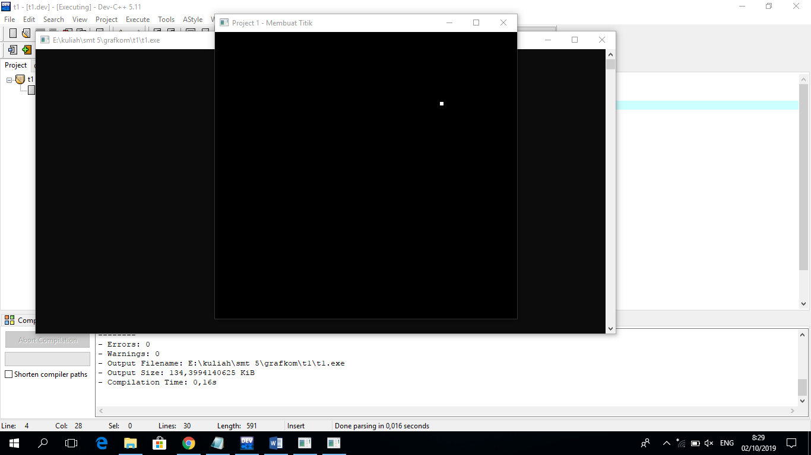**glClear(GL_COLOR_BUFFER_BIT);**

**glPointSize(5.5);**

**glBegin(GL_POINTS);**

**glColor3f(1.0, 1.0, 1.0);**

**glVertex2f(0.5,0.5);**

**glEnd();**

**glFlush();**

**}**

1. **Mengaktifkan beberapa pixel**

**#include <GL/glut.h>**

**#include <GL/glut.h>**

**void titik ();**

**main(int argc, char** argv)**

**{**

**glutInit(&argc,argv);**

**glutInitDisplayMode(GLUT_SINGLE|GLUT_RGB);**

**glutInitWindowSize(600,800);**

**glutInitWindowPosition(100,100);**

**glutCreateWindow("Project 1 - Membuat Titik acak");**

**glClearColor(0.0,0.0,0.0,0.0);**

**glMatrixMode(GL_PROJECTION);**

**glOrtho(1.0,1.0,1.0,1.0,-1.0,1.0);**

**glutDisplayFunc(titik);**

**glutMainLoop();**

**}**

**void titik()**

**{**

**glClear(GL_COLOR_BUFFER_BIT);**

**glPointSize(5.5);**

**glBegin(GL_POINTS);**

**glColor3f(1.5, 0.5, 0.5);**

**glVertex2f(0.5,0.5);**

**glColor3f(0.0, 1.0, 1.0);**

**glVertex2f(0.15,0.15);**

**glColor3f(0.0, 0.0, 1.0);**

**glVertex2f(0.25,0.25);**

**glColor3f(1.0, 0.0, 1.0);**

**glVertex2f(0.35,0.35);**

**glColor3f(0.5, 1.0, 0.5);**

**glVertex2f(0.45,0.45);**

**glColor3f(1.0, 1.0, 0.0);**

**glVertex2f(0.55,0.55);**

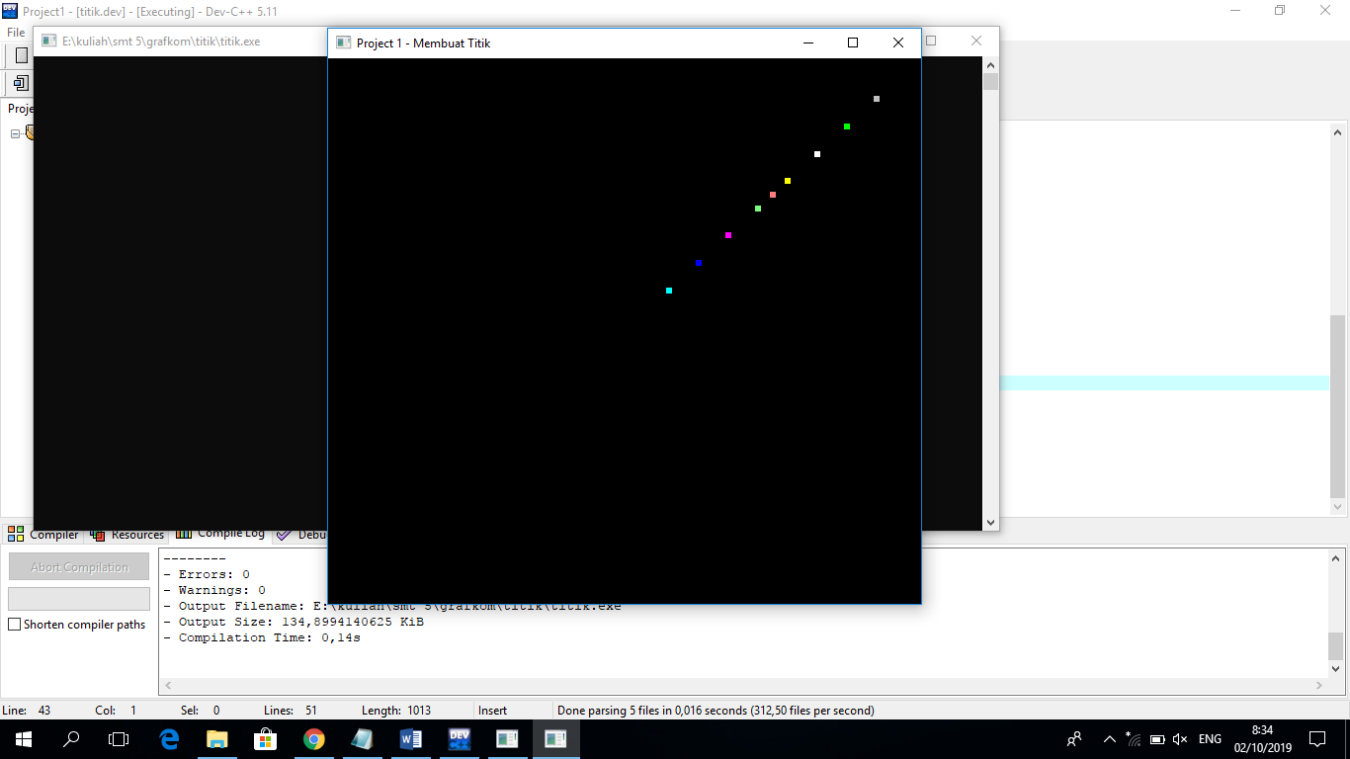

**glColor3f(1.0, 1.5, 8.0);**

**glVertex2f(0.65,0.65);**

**glColor3f(0.0, 1.0, 0.0);**

**glVertex2f(0.75,0.75);**

**glColor3f(0.75, 0.75, 0.75);**

**glVertex2f(0.85,0.85);**

**glEnd();**

**glFlush();**

**}**

1. **Membuat pixel menjadi garis**

**#include <GL/glut.h>**

**#include <GL/glut.h>**

**void titik ();**

**main(int argc, char** argv)**

**{**

**glutInit(&argc,argv);**

**glutInitDisplayMode(GLUT_SINGLE|GLUT_RGB);**

**glutInitWindowSize(600,800);**

**glutInitWindowPosition(50,50);**

**glutCreateWindow("Project 1 - Membuat Titik menjadi garis");**

**glClearColor(0.0,0.0,0.0,0.0);**

**glMatrixMode(GL_PROJECTION);**

**glOrtho(1.0,1.0,1.0,1.0,-1.0,1.0);**

**glutDisplayFunc(titik);**

**glutMainLoop();**

**}**

**void titik()**

**{**

**glClear(GL_COLOR_BUFFER_BIT);**

**glPointSize(5.5);**

**glBegin(GL_POINTS);**

**glColor3f(1.0, 1.0, 1.0);**

**glVertex2f(0.0,0.0);**

**glColor3f(1.0, 1.0, 1.0);**

**glVertex2f(0.025,0.00);**

**glColor3f(1.0, 1.0, 1.0);**

**glVertex2f(0.05,0.00);**

**glColor3f(1.0, 1.0, 1.0);**

**glVertex2f(0.075,0.00);**

**glColor3f(1.0, 1.0, 1.0);**

**glVertex2f(0.1,0.00);**

**glColor3f(1.0, 1.0, 1.0);**

**glVertex2f(0.125,0.00);**

**glColor3f(1.0, 1.0, 1.0);**

**glVertex2f(0.150,0.00);**

**glColor3f(1.0, 1.0, 1.0);**

**glVertex2f(0.175,0.00);**

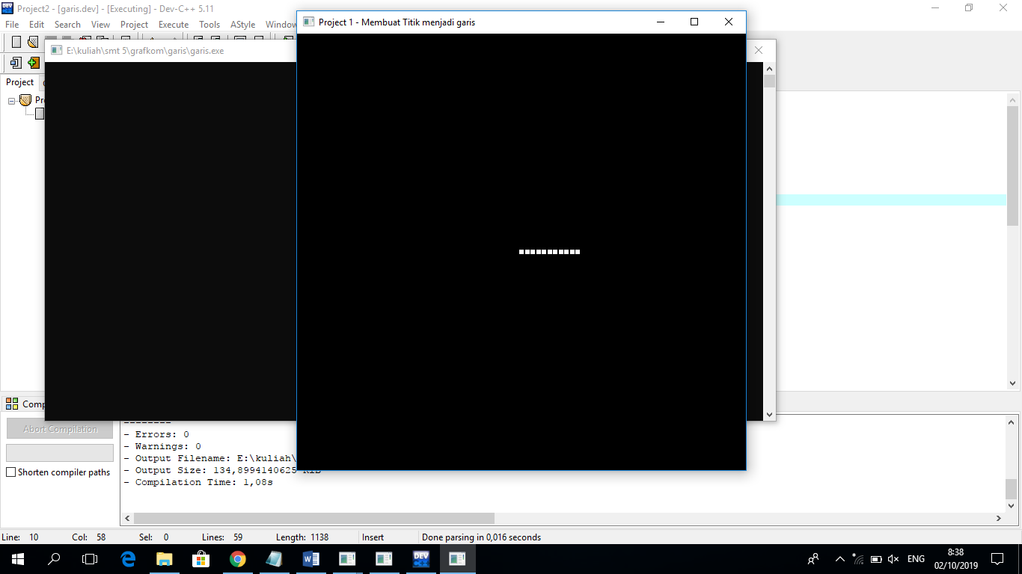**glColor3f(1.0, 1.0, 1.0);**

**glVertex2f(0.200,0.00);**

**glColor3f(1.0, 1.0, 1.0);**

**glVertex2f(0.225,0.00);**

**glColor3f(1.0, 1.0, 1.0);**

**glVertex2f(0.250,0.00);**

**glEnd();**

**glFlush();**

**}**

1. **Membuat pixel menjadi lingkaran**

**#include <gl/glut.h>**

**#include <windows.h>**

**#include <math.h>**

**const double PI = 3.141592653589793;**

**int i,radius,jumlah_titik,x_tengah,y_tengah;**

**void Draw() {**

**glClear(GL_COLOR_BUFFER_BIT);**

**glColor3f(1.0, 1.0, 1.0);**

**glPointSize(5.5);**

**glBegin(GL_POINTS);**

**radius=40;**

**jumlah_titik=60;**

**x_tengah=50;**

**y_tengah=50;**

**for (i=0;i<=360;i++){**

**float sudut=i*(2*PI/jumlah_titik);**

**float x=x_tengah+radius*cos(sudut);**

**float y=y_tengah+radius*sin(sudut);**

**glVertex2f(x/100,y/100);**

**}**

**glEnd();**

**glFlush();**

**}**

**void Initialize() {**

**glClearColor(0.0, 0.0, 0.0, 0.0);**

**glMatrixMode(GL_PROJECTION);**

**glLoadIdentity();**

**glOrtho(0.0, 1.0, 0.0, 1.0, -1.0, 1.0);**

**}**

**int main(int iArgc, char** cppArgv) {**

**glutInit(&iArgc, cppArgv);**

**glutInitDisplayMode(GLUT_SINGLE | GLUT_RGB);**

**glutInitWindowSize(250, 250);**

**glutInitWindowPosition(200, 200);**

**glutCreateWindow("Membuat titik menjadi Lingkaran");**

**Initialize();**

**glutDisplayFunc(Draw);**

**glutMainLoop();**

**return 0;**

**}**

